
2024- 2025 Lesson Plan Template Teacher: MRS. MAYFIELD Subject: ESOL
Week of:  October 20, 2024  -  October 26, 2024 | Monday  October 21 , 2024  ARGUMENTATIVE  TEXTS   | Tuesday  October 22, 2024  ARGUMENTATIVE  TEXTS |  | Wednesday  October 23, 2024  October 24, 2024  ARGUMENTATIVE  TEXTS | Friday  October 25, 2024  ARGUMENTATIVE  TEXTS
TEKS  H.I.S.D. Slides | 9.3 A, 9.7 G  9.9E  SWBAT use  memorizing, comparing, contrasting, and reviewing to acquire new vocabulary.  ELPS 1 A, 1 C | 9.9 E  ELPS 1 B, 1 C |  | 9.6 E , 9.11 A ,  9.11 B  ELPS C 1 E | ELPS: 42,43  4 F, 4 I,  4 j  ELPS C 3,  ELPS C 4  SUMMIT  K - 12  FOUNDATIONAL  SKILLS
Learning Objective | SWBAT analyze  characteristics and structural elements of argumentative texts.  KEY VOCABULARY  - Analyze  - Author  - Conclude  - Decipher  - Details  - Determine  - Evaluate  - Infer  - Inference  NEW  VOCABULARY  - Fiction  - Explicit  - Implicit  - Descriptive  Language  - Mood  - Syntax  - Tone  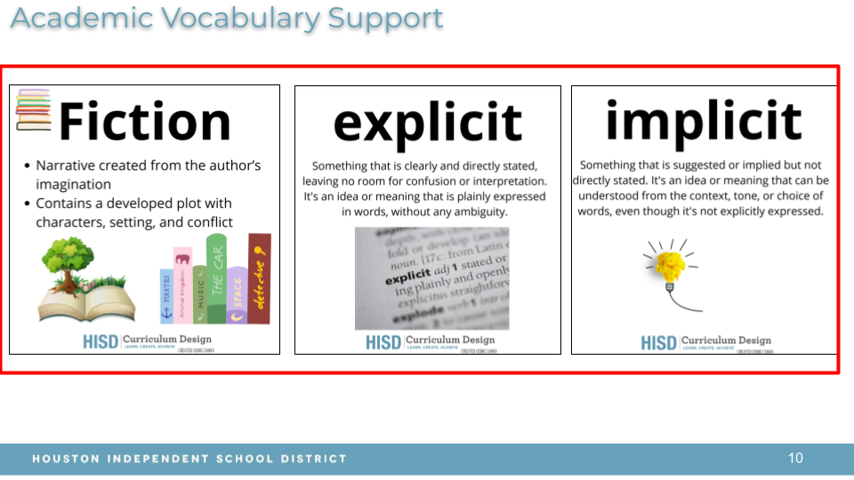 | SWBAT analyze  characteristics  and structural  elements of  argumentative  texts.  DO NOW: (3 minutes)  ⌛ 3 minute timer with music🎵latin funk style music for 180 seconds    STUDENTS: WESTSIDE  HIGH  SCHOOL  Homecoming  Tickets will be on sale from October 25th - October 30th, 2024. |  | SWBAT make connections  within a text.  Ask students if they have ever experienced anything  Similar to the characters from  “Growing Up” by Jessica McBirney or “Growing Up”  By Gary De Soto.  T to play the song, “La Bamba”  By Ritchie Valens  RITCHIE VALENS-LA BAMBA | SWBAT use  multi -  modal  tools to  perform  tasks  while  Connecting  To Literacy  via  Listening & Speaking,  &  Foundational Skills of English  assessments.
Higher Order Thinking Questions | MRS # 1  MRS: Quick Write  RESPONSE  CARDS  Based on what my classmate has said or written on his or her DO NOW..., I disagree that...  T to “Think Aloud”  Senor Noboa    T to remind students  that last week we  Discussed the Direct Characterization of Senor Noboa when we read, “Senor  Noboa”  By Raul Leis and  Translated by  Leland H. Chambers.  Teacher to use student examples from the large notecards (Think - Pair - Share ) from last week.  A few of you wrote that Senor Noboa was mean or cruel to his workers. In the picture, you said,  “He looks angry or he looks unhappy. We know this by his frown.”  “He is hunched over on his white horse. “  MRS 2: Ink -  Pair -  Share  3 Minute Timer  Discuss what Senor Noboa’s Indirect Characterization is with your  Table partner who is seated across from you . You have three minutes. I will count down and when I say, “GO !”, begin to discuss your answers.  T to say, “Three,  Two,  One,  GO ! “  https://youtu.be/RK27RX54EJU?si=9kcj3K-vhgwqkZLs  When the timer sounds, T does an attention grabber to bring students back together. | INTERVENTIONS:  Help students write or copy sentence stems.  Sentence stems , Signals,  Images, Total Physical Response actions  MRS: Short -  Constructed  Response -  Response Cards  EMOTION - AFRAID  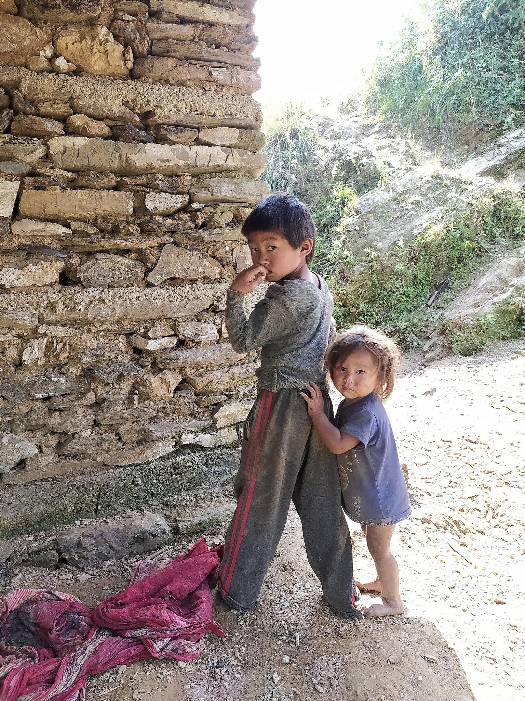  ________________  _________________ . |  | How can one’s identity be discovered by making  difficult choices and staying true to oneself?  Why would a person choose to live on the fringes of society and not feel like an outcast ?      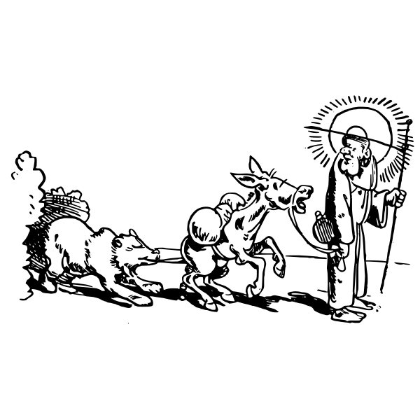 ⁉️    Have you ever lived through  a natural catastrophe?          Have any of your family members or friends suffered from poor health due to chemical poisoning or excessive heat ?  What is a solution to prevent these adverse effects in the future ?   | Weekly Wrap - Up  T to remind students  that we compared an excerpt of a short - story.  “HERS: A Puerto  Rican Stew”  By Esmeralda  Santiago  To  “An American Girl”  By  Julia Alvarez looking at the Exemplar Venn Diagram that Mrs. Mayfield posted .  We read  Señor Noboa  (The Adapted Version)  By: Raul Leis  Translated by: Leland H. Chambers,  And identified  Explicit and implicit meanings through personalities of characters as well as the linear and non - linear plot in  Señor Noboa  (The Adapted Version)  By: Raul Leis  Translated by: Leland H. Chambers.  Hispanic Heritage Month  ended on  October 16th.  Americans in  The United States of America celebrate  Hispanic Heritage Month  Because  “Latinos continue to help fuel our economy and enrich our nation as  Astronauts,  engineers,  entrepreneurs, athletes, artists, entertainers, scientists, public servants. 2024 is “Pioneers of Change: Shaping the Future Together”.  .
Agenda | DO NOW:  (Five  Minutes)  Students, copy this quote and then write if you agree or disagree.  Then, justify your responses.  “Growing - up in a foreign country is easy because we can make many friends and life becomes an extended vacation”  Write: 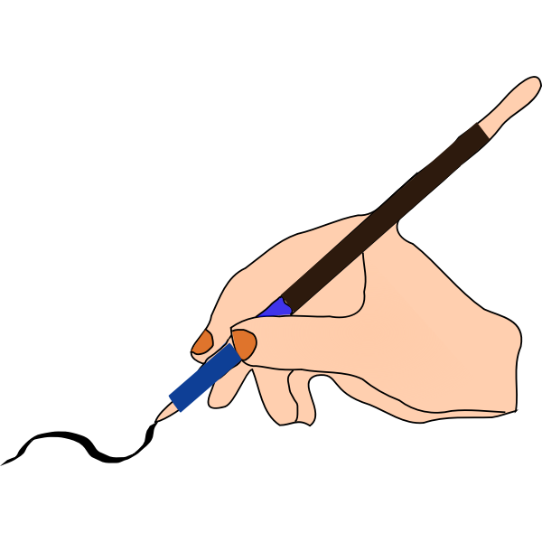  I agree with this statement because  growing - up in a foreign country…  It is like a vacation because _________  ________________ .    OR  I disagree with this statement because growing - up in a foreign country is….  (Possible answers:  Stressful if we do not know how to speak the language.    Frustrating if we do not know the customs.  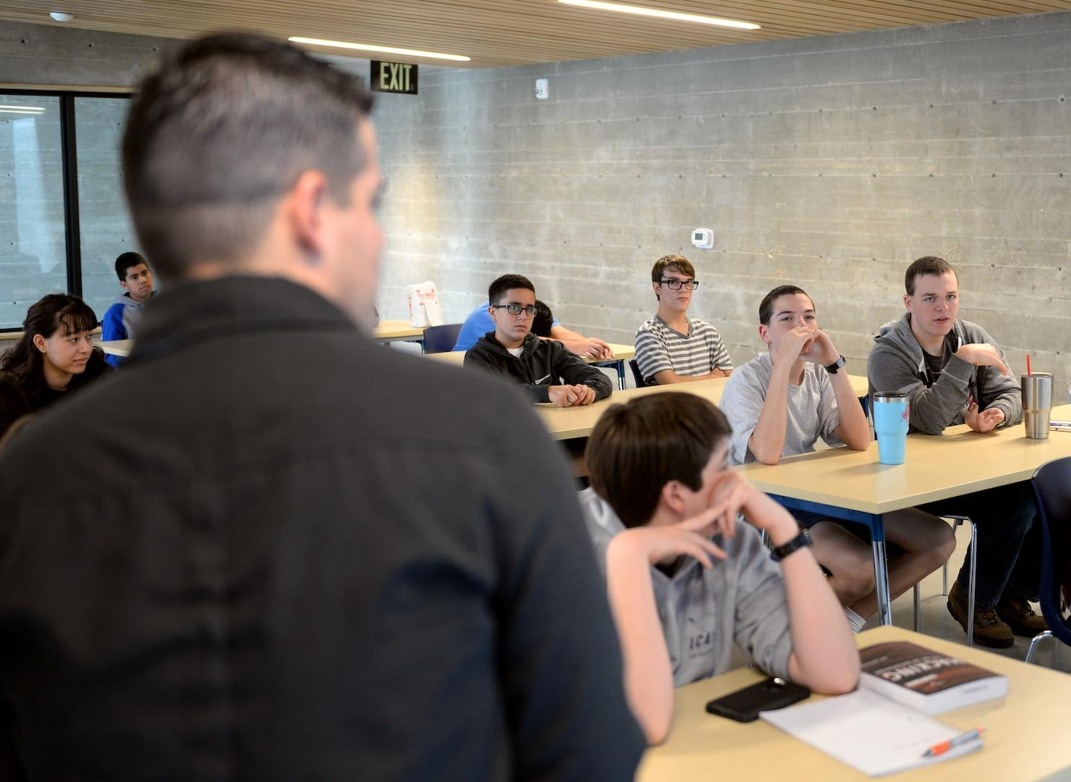  Unbearable because I left my family to come here and I miss them so much.  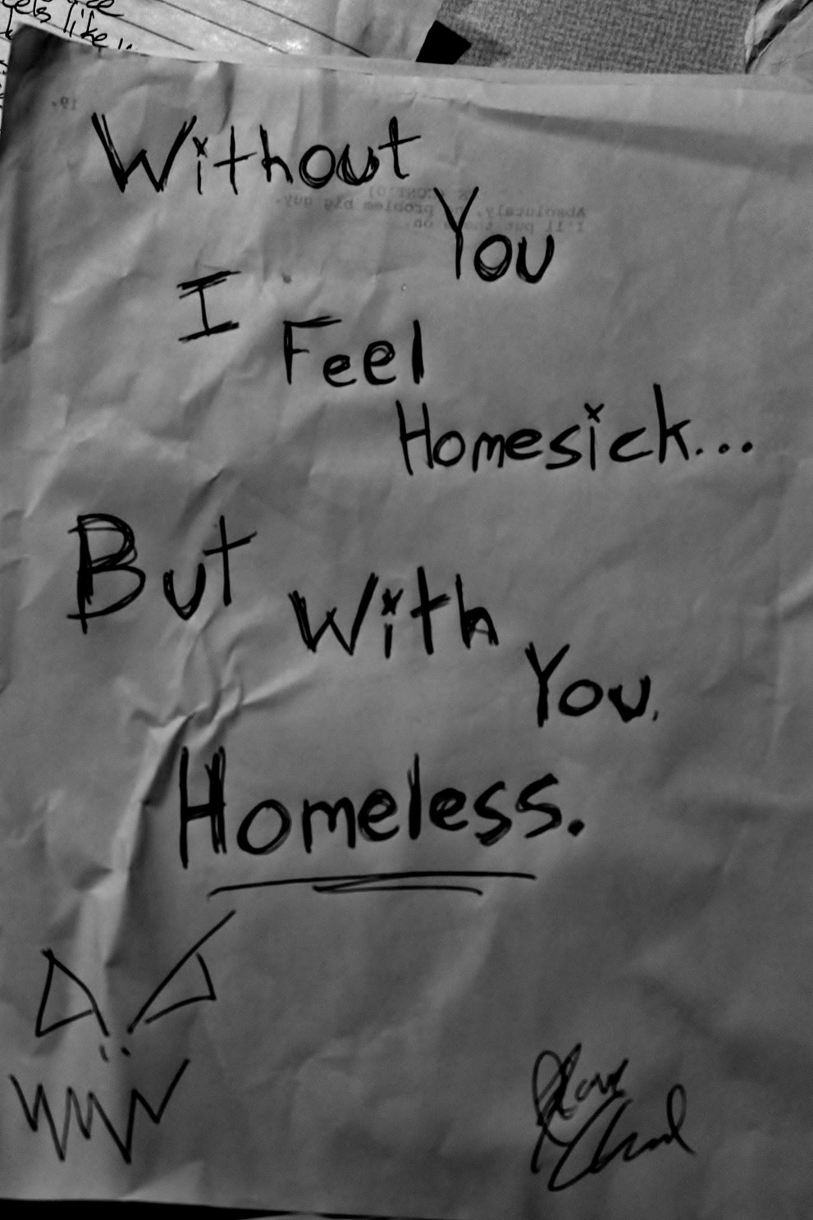    - MRS # 1  - Review last week’s story with this week’s new story.  - MRS # 2  - Teacher explains what Argumentative Writing is to the class.  Argumentative Writing is defending a claim or stance that can be debated by another person or group of people.  Students to copy definition of Argumentative Writing.  - T does  first  READING  - Growing up: Key Moments”  By: Jessica McBirney  - H.I.S.D.  Slides  - Higher  Order  Thinking  QUESTIONS  A What  changes can happen to a person as they are growing up ?  Think about physical changes.  From toddler -  Child –  Adolescent -  Pre - Teen  2 Minute Timer with Music [ELECTRIC] ⚡  B What  changes  do you wish your parents would have made to make your childhood better ?  C What  kind - of childhood did your parents have ?  What opportunities or privileges were you given that they were not?  6)  Demonstration of Learning.  - EXIT TICKET  Turn and Talk:  Only use one sheet of paper. Write the partners’ names, today’s date, and students’ class period on the notebook paper.  In the center of the notebook paper, write,  EXIT TICKET .  One partner copies the question.  What is the purpose of a claim in argumentative writing?  - To ignore the author’s position.  - To share the author’s position.  - To share the reader’s position.  - To share why growing up is a good thing.  Student A  Both partners discuss.    The other partner writes the answer on the sheet of notebook paper and turns it in to the Class Period Tray (Tray 4,5,  6, 7, 8) .  Student B   | - DO NOW:  QUIZLET LIVE:  Review New  Vocabulary with students.  - Fiction  - Explicit  - Implicit  - Descriptive  - Mood  - Syntax  - Tone  2) Re - read the story,  “Growing Up” by  Jessica McBirney  3) MRS : Modified  Whip  Around  Tell the classmate in back of you what  4) SEL Emotion  Anchor  Chart  How are you  Feeling?  4) Ask students to look  at explicit clues in the  text to make  inferences about how  the character from,  “Growing up: Key Moments” By: Jessica McBirney is  Feeling.  The character is feeling  ___________________  and I know this because  ___________________ .  Students to cite evidence from the story.  REMIND students of yesterday’s question:  What is the purpose of a claim in argumentative writing?  - To ignore the author’s position.  - To share the author’s position.  - To share the reader’s position.  - To share why growing up is a good thing.  2) “Growing Up”  By  Gary De Soto    Students, what is the main idea that you listened to in this story ?  What is the theme of this story ?  How is this story similar to Jessica McBirney’s story, “Growing Up” ?  How is it different from  Jessica McBirney’s story,  “Growing Up” ?  The character is feeling  ___________________  and I know this because  ___________________ .  (Maria is the fourteen year old character) . |  | DO NOW:  - Show exemplar of Venn  Diagram  Of “Growing Up”  By  Jessica  McBirney  To  “Growing Up”  By  Gary De Soto  T to guide students through  The Venn Diagram  Graphic Organizer  (Five Minutes)  https://youtu.be/4Lhnu3deitk?si=b-cdCRKAImfWtAOj  - MRS: ORAL CHORAL  One comparison between  “Growing Up by Jessica McBirney and “Growing Up” by Gary De Soto is that the main characters are teenagers growing up . They experience the same emotional feelings. They center around hardships and loss of childlike innocence.  - Listen to Audio of  Gary De Soto’s  “Growing Up”  "Growing Up" by Gary Soto  MRS # 3  One contrast between  “Growing Up” by Jessica McBirney and “Growing Up” by Gary De Soto is that the first story is an informational piece while the second story is a narrative piece. The first story is argumentative. The second story illustrates how familial tension causes arguments between family members. Although childlike innocence disappears when one grows - up, it should not always carry a negative connotation.  - Students to fill - in  Their Venn Diagram  Graphic Organizers . | - DO NOW:  Quick Write  How does an Ex - Pat, Foreigner, or Refugee achieve  “The American Dream  ?”  T to play Podcast and students listen to it  before writing their responses.  T to use large, blank  Anchor Chart Paper  To write an  Example.  Then T passes one  Large, blank sheet of Anchor Chart Paper to each group. Students to brainstorm about how to answer the question.  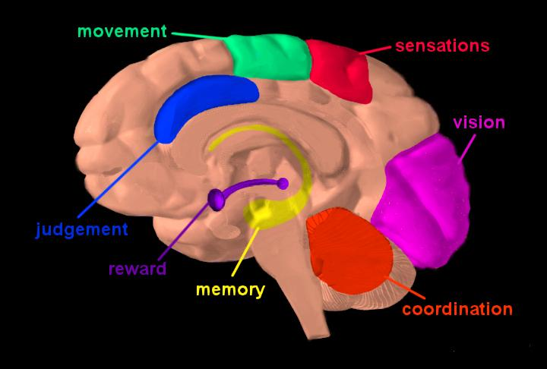  Next, students to draw a symbol of what places or things represent “The American Dream” onto the large sheet of paper. They will color the symbol. They will answer why they chose the symbol.    One of the students will write the sentence that the students collaborated on,  “A foreigner can achieve The American Dream by … “ onto the large white sheet of paper.  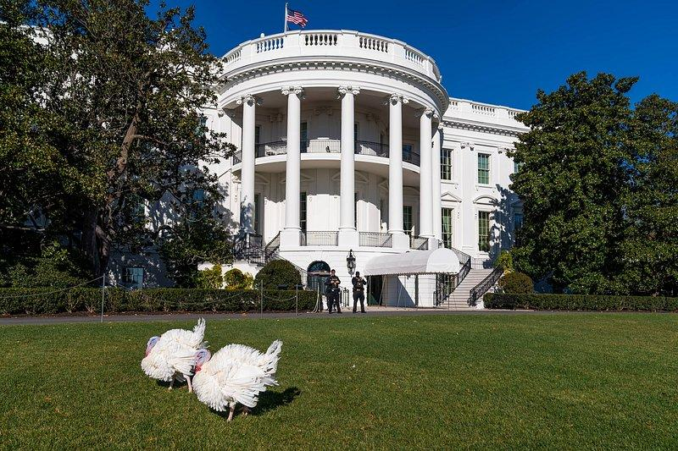  The last student will present their group’s answer, symbol, depiction of The American Dream to the class.  (Reading, Writing, Speaking, Listening) .  - Students to  Continue  Completing tasks and interactive assignments on SUMMIT  K - 12 ,  FOUNDATION  SKILLS
Demonstration of Learning | Given a text, students will analyze characteristics and structural elements with at least 80% accuracy.  Growing up: Key Moments  (Adapted text: Argumentative)   | Given a text, students will analyze how the author’s use of language, diction and syntax informs the reader and contribute to the tone with at least 80% accuracy. |  | Given a text, students will use an organizing structure appropriate to the purpose and audience to develop the argument, with at least 80% accuracy. | Given that students have evaluated texts revolving around themes of Learning English, Emigrating to a Foreign Country, and Changes in One’s Identity caused by moving to another country and by growing - up,  students will understand that their lives will endure hardships, tribulations, and learning moments.  By way of a digital platform that aids in The  Building Blocks  of The Fundamentals of  English, students practice Writing to achieve TELPAS FOUNDATION SKILLS Benchmarks.
Intervention & Extension | INTERVENTIONS:  IMAGE 1    - If this visual could talk, it would tell me _______.  - Analyze the setting – Three important words in the setting of this picture are _______, _______, and _______  because __________.  IMAGE 2    - If this visual could talk, it would tell me _______.  - Analyze the setting – Three important words in the setting of this picture are _______, _______, and _______  because __________.  EXTENDED LEARNING  Compare and Contrast Image 1 to  Image 2.  EXTENSION:    ​  Upload  Vocaroo - The premier voice recording service.  Go to VOCAROO.com  And record your DO NOW answer.  Then e - mail it to your Guardian or Parent.  www.Vocaroo^{com} | INTERVENTIONS:  Accommodations:  Chunk Information,  Allot extra time to  Complete assignments.  Digital dictionaries.  Oxford Picture  Dictionary  One - on - One  Time with the  Teacher |  | INTERVENTIONS:  Once Classwork has been completed, students to either work on Learning Chocolate -  (ELDA Newcomers)    OR  SUMMIT K - 12  (ESOL I, II)  Individual assistance on the  digital platform Summit K-12 .  T to meet one - on - one with  students to show Data Reports  and make individual goals based  on personal strengths and  weaknesses. | INTERVENTIONS:  Learning For  CHOCOLATE  Picture Platform    Shapes  new    Ways to Get Around  new  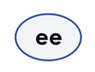  Long /ē/ Sound EE  new  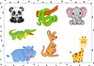  Jungle and Zoo Animals  new  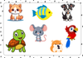  Pet Animals  new  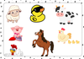  Farm Animals  new  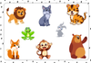  Jungle and Forest Animals  ns  new    Home and Neighborhood Adjectives  new    My Clothes  new  User Favorites  See all ...    Months    Weather    Numbers 1    Family Tree 1    Personal Pronouns  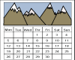  Most Viewed this Mo  Months  Numbers 1    Alphabet Phonics A-Z    Numbers 1-20  Days  Weather    The English Alphabet    Basic Colors    Daily Routine 1    Feelings - How Do You Feel?
Resources  Pencils  Blue or Black ink pens  Highlighters  H.I.S.D. Slides  # s 16 - 20  Adjective Anchor  Chart  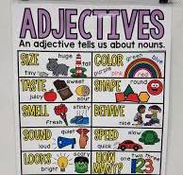 | INTERVENTION  YouTube:  What did you do on the weekend? ESL/ESOL Speaking practice | English Portal  www.ESLSTUDENTSWhatDidYouDoThisWeekend?”  What did you do on the weekend? ESL/ESOL Speaking practice | English Portal  Bilingual Dictionaries  H.I.S.D. Slides  # s 21 - 24  Emotion Anchor  Chart  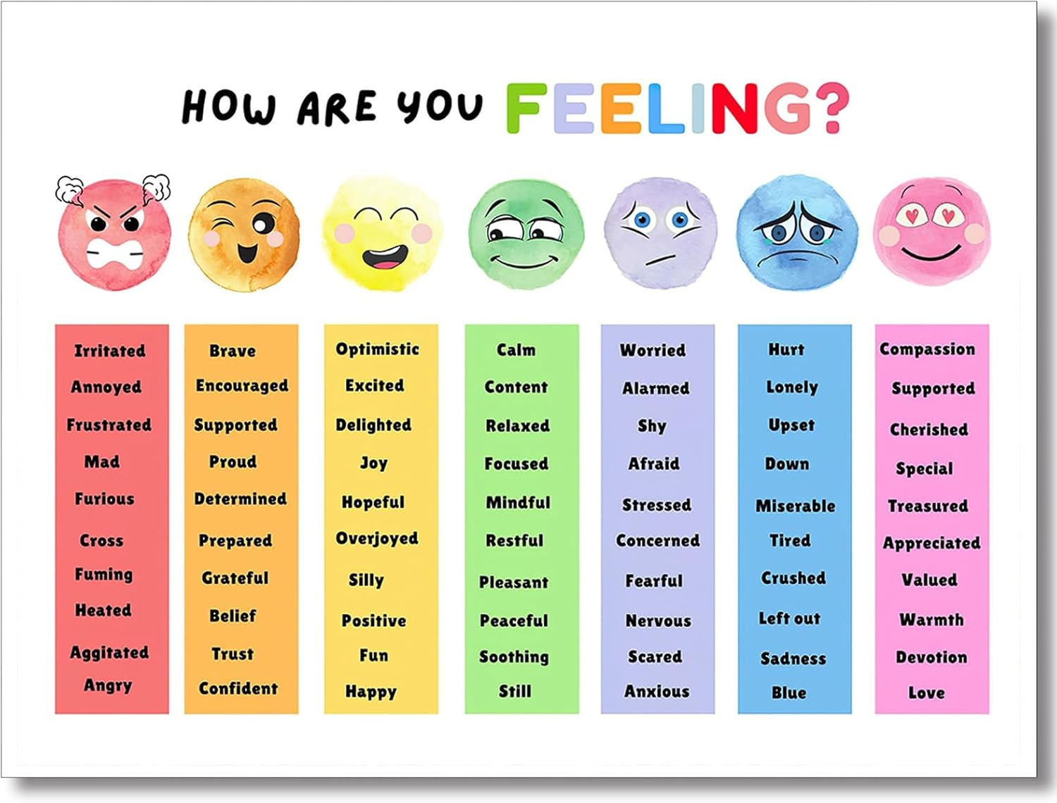 | QUIZLET  FLASHCARDS  QUIZLET LIVE  Created by Mrs. Mayfield, notecards,  Printed excerpt of stories,  Bilingual Dictionaries  H.I.S.D. Slides  #s 25 - 27  Emotion Anchor  Chart |  | Audio story, Paper Story,  Podcast  “Growing Up”        Señor Noboa  (The Adapted Version)  By: Raul Leis  Translated by: Leland H. Chambers | Anchor Chart  Lap - tops  

